Optical properties of a simple metal “Aluminium”
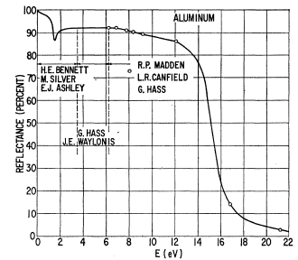
In the laboratory we measured the reflectivity of the simple metal “Aluminium”, the data are presented in the fig1
The optical properties of a simple metal are well described by Drude model.
In this contest try to find:
- The plasma frequency
- The dielectric function (the real ε1 and the imaginary ε2 parts) use Reffit program
- The scattering rate τ.
Figure 1: Reflectance of Al
- Could you extract effective mass?
Now use the Mstudio program and try to simulate the dielectric function of Al.
Compere the experimental results to the simulations.
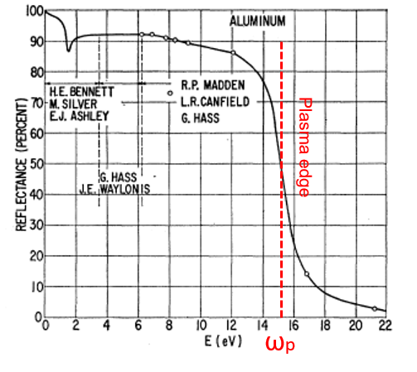
Correction:
For a simple metal the plasma edge separates two well define regions: a region with perfect reflectivity R⁓1 and a perfect absorption R=0
The plasma edge defines the plasma frequency, In the case of Al, $ω_{p}=15 eV=120984 {cm}^{-1}$

The reflectivity (R) and the dielectric function (ε) are related by:
$R\left(ω\right)={\left|\frac{1-\sqrt{ε}}{1+\sqrt{ε}}\right|}^{2}$
Where $ε=ε_{1}+iε_{2}$
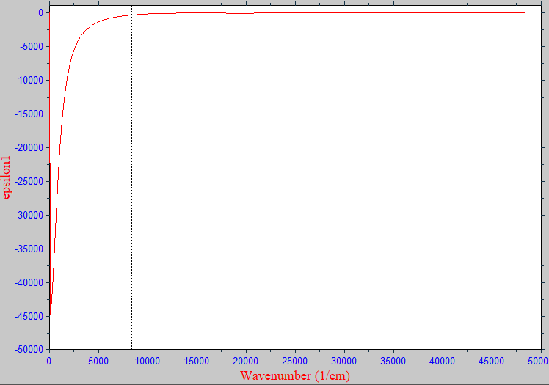
Using this relation, the program reffit calculates the $ε_{1}$and $ε_{2}$

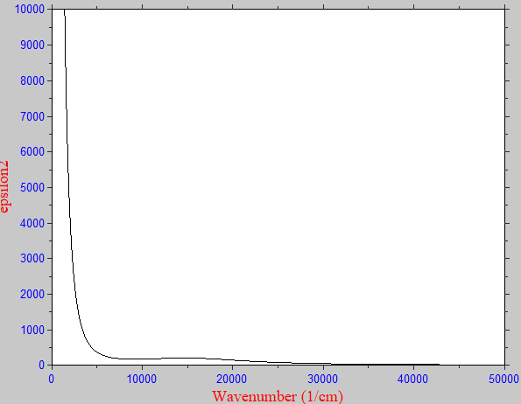

we compare with the experimental data:

To extract the scattering rate τ, we need the calculate the optical 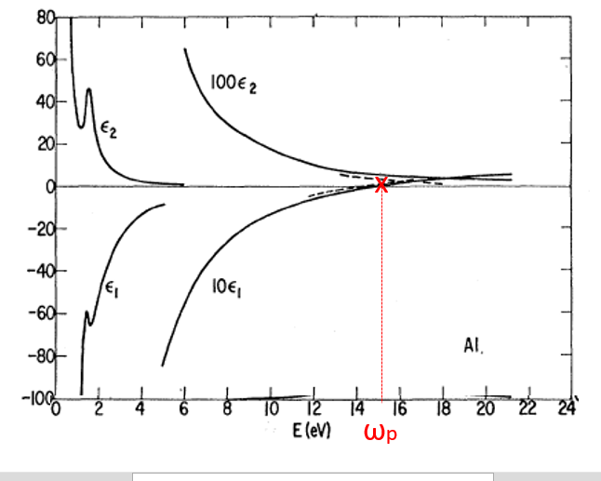conductivity σ(ω).
$$\frac{1}{τ}(ω)=\frac{2π}{z}ω_{p}^{2}Re(\frac{1}{σ(ω)})$$
z=377Ω vacuum impedance.
And σ(ω) is related to ε(ω)
$σ\left(ω\right)=2πi\frac{ω}{z}(1-ε$)
Where $σ=σ_{1}+iσ_{2}$

$$σ_{1}=\frac{ωε_{2}}{4}$$
$$σ_{2}=\frac{ω}{4π}(1-ε_{1})$$

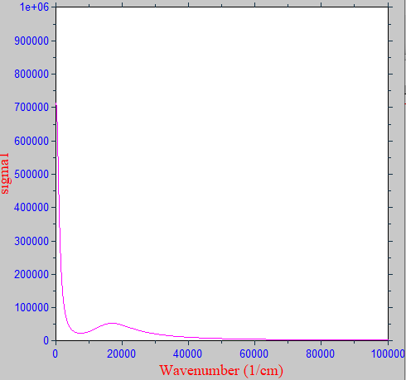

$$σ=\frac{σ_{0}}{1-iωτ}$$

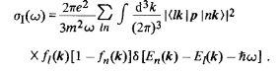
Now go to Mstudio and do band structure calculations:
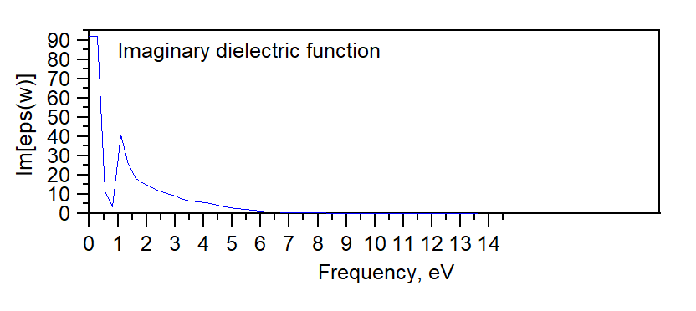
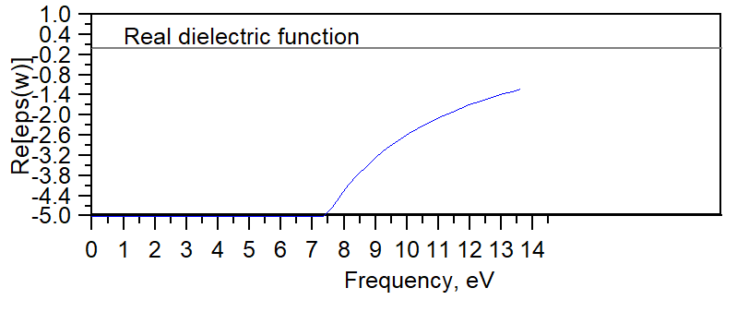

H. EHRENREICH et al. PHYSICAL REVIEW.132.1918

